Posljednje predavanje Seyyeda Hosseina Nasra na Univerzitetu George Washington
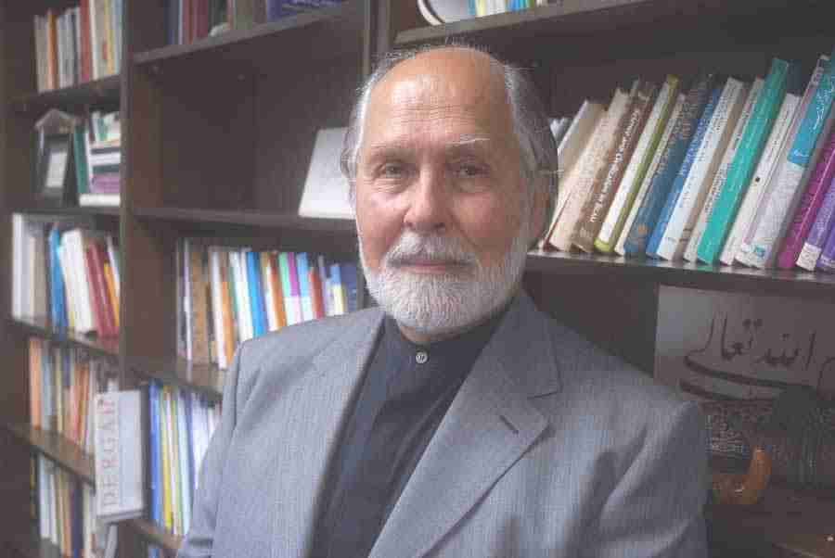
Nakon više od 40 godina predanog podučavanja na Univerzitetu George Washington, prof. dr. Seyyed Hossein Nasr (https://www.seyyedhosseinnasr.com/) održati će svoje posljednje predavanje u četvrtak, 4. 12. 2025. godine. Ovim predavanjem proslavlja se njegova nevjerovatna karijera vodećeg muslimanskog mislitelja danas, koja je počela 1958. godine u Iranu i nastavljena 1979. u USA, kao i njegov kolosalni opus od 90 knjiga i preko 600 tekstova u vodećim časopisima.
Kolege i prijatelji profesora Nasra su već objavili svezak u njegovu čast koji će mu biti uručen na internacionalnoj konferenciji na the GWU, 14. 11. 2025. godine:
I of the Heart: Texts and Studies in Honor of Seyyed Hossein Nasr
(Ja od srca: Tekstovi i studije u čast Seyyeda Hosseina Nasra)
uredili Muhammad U. Faruque, Atif Khalil & Mohammed Rustom (Leiden-Boston: Brill, 2025.)
Profesor Nasr je prije 25 godina posjetio Univerzitet u Sarajevu, Zagrebu i Prištini i održao svoj javni ciklus predavanja u septembru 2000. godine.

Seyyed Hossein Nasr's last lecture at George Washington University
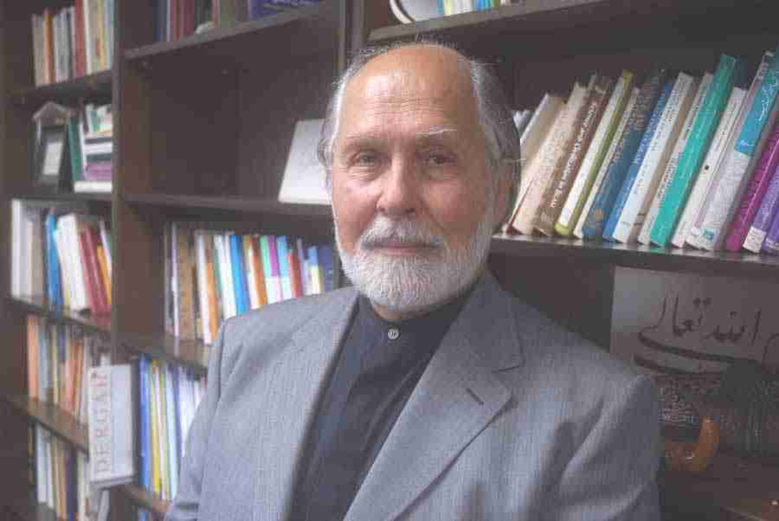
After more than 40 years of dedicated teaching at George Washington University, Professor Seyyed Hossein Nasr (https://www.seyyedhosseinnasr.com/) will deliver his final lecture on Thursday, December 4, 2025. This lecture celebrates his incredible career as a leading Muslim thinker today, which began in 1958 in Iran and continued in 1979 in the United States, as well as his colossal oeuvre of 90 books and over 600 articles in leading journals.
Professor Nasr's colleagues and friends have already published a volume in his honor, which will be presented to him at an international conference at the GWU on November 14, 2025:
I of the Heart: Texts and Studies in Honor of Seyyed Hossein Nasr
Edited by Muhammad U. Faruque, Atif Khalil, and Mohammed Rustom (Leiden-Boston: Brill, 2025.)
Professor Nasr visited the Universities of Sarajevo, Zagreb, and Pristina 25 years ago and delivered his public lecture series in September 2000.

