 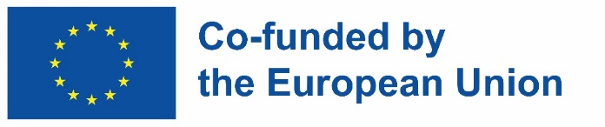

**Tutorial as part of the project**

**GEDIS – Gender Diversity in Information Science: Challenges in Higher Education**

**in Zadar, Croatia**

University of Sarajevo as a partner of the project GEDIS – **Gender Diversity in Information Science: Challenges in Higher Education,** 2024-1-ES01-KA220-HED-000246558

As part of the Erasmus+ project GEDIS – **Gender Diversity in Information Science: Challenges in Higher Education**, a tutorial entitled "Curriculum Redesign in LIS: Recommendations for Integrating Gender Diversity" organized by the partner of the project University of Zadar (Croatia), was held in Zadar, Croatia, from 4 to 6 June 2025, which was attended by representatives from the Chair of Information Sciences of the University of Sarajevo – Faculty of Philosophy Associate Professor Dr. Lejla Hajdarpašić and Assistant Professor Dr. Džejla Khattab.

In addition to the representatives of the tutorial organizers from the University of Zadar (Croatia), the training was attended by representatives from the University of Barcelona (Spain), which is the coordinator of the project, as well as representatives of partner institutions: University of Hildesheim (Germany), Carinthia University of Applied Sciences (Austria), Josip Juraj Strossmayer University of Osijek (Croatia), University of Sarajevo (Bosnia and Herzegovina) and Silesian University of Opava (Czech Republic).

The participants of the tutorial were presented with recommendations for the inclusion of gender diversity in curricula in Library and Information Sciences (LIS), and the training was realized through the following thematic units: Conceptualization and Terminology; Critical Analysis, Tools and Practical Examples; Content Creation and Action Plans.

The Erasmus+ GEDIS project, in which the University of Sarajevo is a partner, is implemented from 2024 to 2027 and is focused on the integration of the gender perspective in higher education, with a special focus on Library and Information Sciences (LIS), whereby the project contributes to the creation of more inclusive and equitable universities, aligning with the priorities of the European Union in the field of equity and innovative education. The key result of the project refers to the development of three educational toolkits intended for students, teachers and library staff, in English, Spanish, Catalan, German, Bosnian, Croatian and Czech.

For more information about the project, please visit: <https://www.ub.edu/gedis>