Announcement regarding Nevad Kahteran's participation in MGCIS-ICCCF 2026, Kuala Lumpur
(brochure attached)
The pre-recorded video contribution by Nevad Kahteran for
MALAYSIA GLOBAL CIVILIZATIONAL INITIATIVE SUMMIT 2026
Islam-Confucian Civilizational Cultural Festival (MGCIS-ICCCF 2026, Booklet)
马来西亚全球文明倡议高峰论坛
暨
儒伊文明文化节
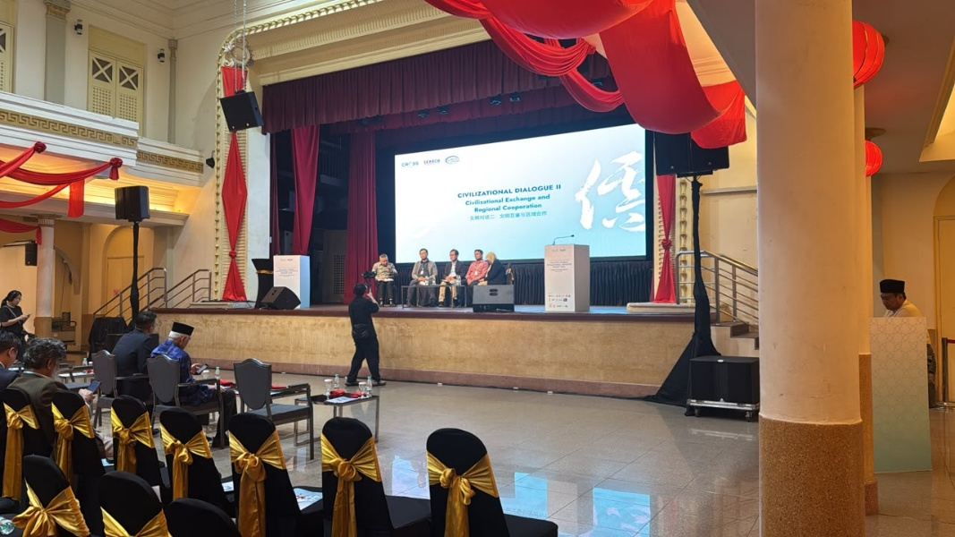

See the link: https://www.youtube.com/live/X9ixlO7-Erw?si=5LKj9zTl3K0EZ03c

Obavijest o učešću Nevada Kahterana na MGCIS-ICCCF 2026, Kuala Lumpur (brošura u privitku)
Unaprijed snimljeni video-prilog Nevada Kahterana za
Samit Globalne inicijative civilizacija Malezije 2026. (MGCIS 2026)
Festival islamske i konfucijanske civilizacije i kulture (MGCIS-ICCCF 2026, brošura)

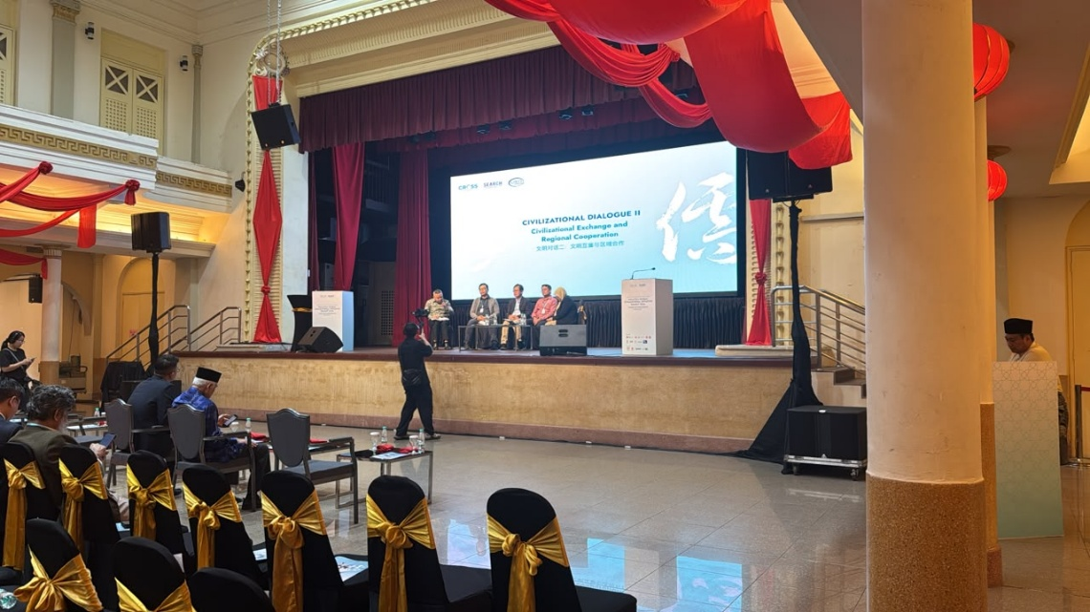

Vidjeti link : https://www.youtube.com/live/X9ixlO7-Erw?si=5LKj9zTl3K0EZ03c

