Obavijest
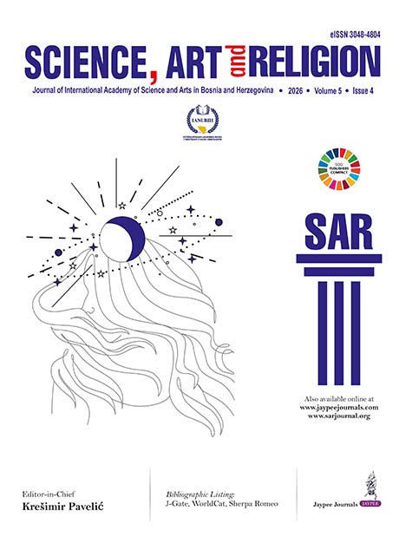
Profesor Nevad Kahteran, redovni profesor sa Filozofskog fakulteta je objavio dva svoja rada u časopisu Internacionalne akademije nauka i umjetnosti u Bosni i Hercegovini (IANUBiH) Science, Art and Religion: Science, Volume 5 Issue 4 (October–December 2026: https://sarjournal.org/journal/SAR, eISSN: 3048-4804):

Kahteran N. Philosophy as Metanoetics by 田辺元 Tanabe Hajime (1885–1962): Its Significance for Bosnia and Herzegovina and the Region. Sci Arts Relig 2026;5(4):159–164; DOI: 10.5005/jp-journals-11005-0142, dostupan online:
https://sarjournal.org/abstractArticleContentBrowse/SAR/83/5/4/47677/abstractArticle/Article; i

Kahteran N. Redefining Defining Philosophy by James W. Heisig. Sci Arts Relig 2026;5(4):170–177; dostupan online:
https://sarjournal.org/abstractArticleContentBrowse/SAR/83/5/4/47679/abstractArticle/Article.

Announcement
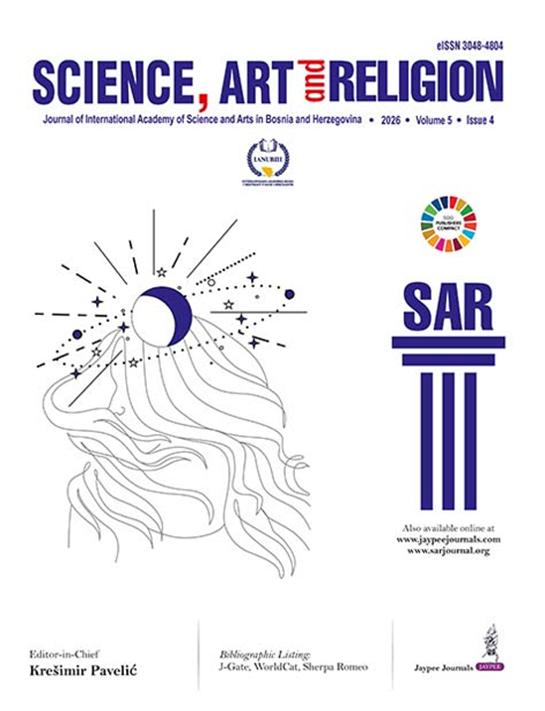
Professor Nevad Kahteran, a full professor at the Faculty of Philosophy, has published two papers in the journal of the International Academy of Sciences and Arts in Bosnia and Herzegovina (IANUBiH), Science, Art and Religion, Volume 5, Issue 4 (October–December 2026: https://sarjournal.org/journal/SAR; eISSN: 3048-4804):

Kahteran N. Philosophy as Metanoetics by 田辺元 Tanabe Hajime (1885–1962): Its Significance for Bosnia and Herzegovina and the Region. Sci Arts Relig 2026;5(4):159–164; DOI: 10.5005/jp-journals-11005-0142, available online: https://sarjournal.org/abstractArticleContentBrowse/SAR/83/5/4/47677/abstractArticle/Article; i

Kahteran N. Redefining Defining Philosophy by James W. Heisig. Sci Arts Relig 2026;5(4):170–177; DOI: 10.5005/jp-journals-11005-0146, available online:
https://sarjournal.org/abstractArticleContentBrowse/SAR/83/5/4/47679/abstractArticle/Article.

